**Data Structure Assignment No.1**

**Questions 1:**

Given the following jumbled word, OBANWRI guess the correct English word.

ANS:- RAINBOW

**Questions 2:**

Write a program which prints “LETS UPGRADE”. (Please note that you have to

print in ALL CAPS as given)

ANS:- 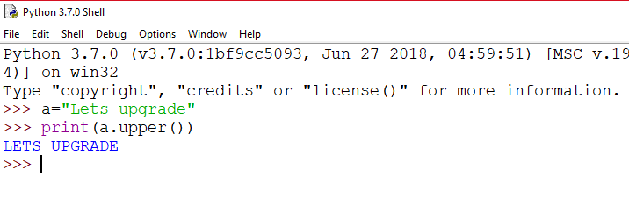

**Questions 3:**

Write a program that takes cost price and selling price as input and displays whether the transaction is a

Profit or a Loss or Neither.

INPUT FORMAT

The first line contains the cost price.

The second line contains the selling price.

OUTPUT FORMAT

Print "Profit" if the transaction is a profit or "Loss" if it is a loss. If it is neither

profit nor loss, print "Neither". (You must not have quotes in your output)

**Code :-** 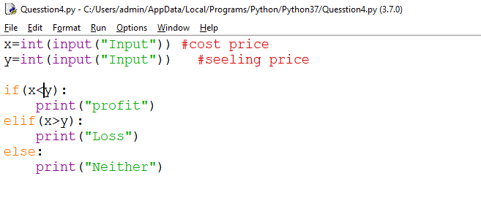

OUTPUT:-

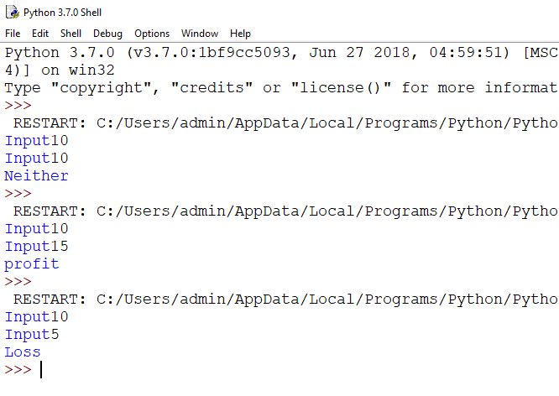

**Questions 4:**

Write a program that takes an amount in Euros as input. You need to find its equivalent in

Rupees and display it. Assume 1 Euro equals Rs. 80.

Please note that you are expected to stick to the given input and output

format as in sample test cases. Please don't add any extra lines such as

'Enter a number', etc.

Your program should take only one number as input and display the output.

**CODE:-**

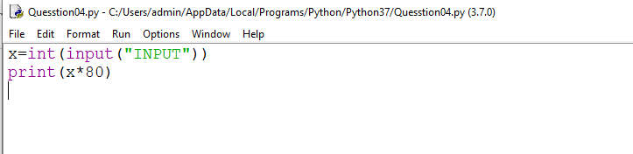

**OUTPUT:-**

